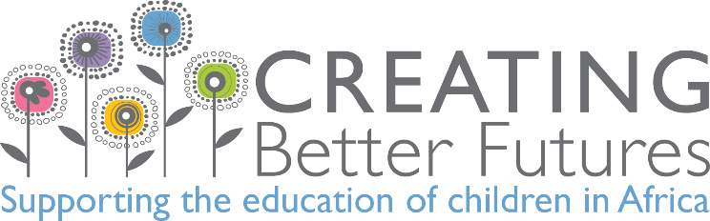

Social Media Executive
(this is an unpaid volunteering role)

Creating Better Futures is a Christian-led charity, based in Reading. We help children, many orphaned as a result of AIDS, and their guardians in rural Zimbabwe. We’ve been nominated for Pride of Reading Award, Charity of the Year 2016.

We work in partnership with Rotary International District 1090 (Thames Valley) and our projects are overseen by Rotary Club of Harare. We have similar values and work with local Rotary clubs in both the UK and Zimbabwe. We focus our efforts on supporting the education of children in Africa. We work with local communities to help provide clean water and nutritional food to fight disease.

Our volunteers give their expertise and time for free, our premises are rent free and we keep our running costs to a minimum. Our Zimbabwean team provides real time information about what’s happening on the ground. We work directly with local communities and schools to identify their specific needs.

Our Child Sponsorship Programme and Feeding Programme prove to be life changing to children we support.
We sponsor 177 children (£15 a month each) and feed 2,218 children every day during term time (£1 feeds one child for a month).

Social media is a powerful way of encouraging people at churches, clubs, schools, organisations and companies to campaign for, donate to, fundraise for and support our activities.

Our aim is to engage supporters, motivate fundraisers, encourage volunteers and increase donations to www.justgiving.com/creatingbetterfutures

We’re looking to maintain varied, social media posts that increase awareness and spread the positive message about how CBF supports the education of children in Africa.

What activities will you be involved in?
- Creating posts that encourage people to like and retweet to maximise engagement
- Using our social media framework and guidelines to brainstorm a post idea and decide on relevant content
- Deciding desired response, what post is about, who it’s aimed at and how you’ll grab their attention
- Who we are, what we do and what we need…
- Ensuring ever post includes key message, relevant/ trending hashtag, relevant URL and call-to-action (CTA)
- Making sure your post has a call-to-action; engage, motivate, donate, sponsor, CBF website or information
- Writing copy in Word so spelling and grammar are automatically corrected to minimise errors
- Being meticulous in checking dates, hashtags, images, links, times and web addresses
- Source relevant picture from our image library stored on Google Drive
- If necessary, sourcing relevant copyright-free image from Internet
- Liaising with our Zimbabwean volunteers if new photography is needed
- Adding CBF logo, and text if required, to images you’re using
- Creating a post using Canva graphic design software
- Scheduling and uploading your posts into Hootsuite
- Checking social media platforms frequently throughout the day so engagements can be responded to quickly
- Keeping each platform open on a browser ‘tab’ to browse through trends and respond to engagements
- Keeping aware of daily trending topics and what other companies are posting about
- Being aware of likes, shares, retweets and engagement for each post
- Keeping analytics on individual post reach and engagement; report on which posts are most successful
- Maintaining social media calendar to incorporate relevant national awareness days
- Looking at how other charities, and CBF, promoted their work last year on a particular awareness day
- Researching national awareness day websites to see how they promote themselves
- Communicating with Digital Marketing team using Google Hangouts, WhatsApp and Outlook
- Working closely with our volunteer teams in the UK and Zimbabwe

What skills and abilities will you need to have?
- To be highly skilled at presenting information online and in print
- Taking a pride in your work and constantly paying attention to detail
- Proof reading skills to find errors and omissions
- Ability to use simple and clear language to ensure your words and messages connect with our readers
- Planning ahead so social media content isn’t rushed
- Managing content across existing social media channels; Facebook, Google+, Instagram, Linkedin, Twitter, YouTube and recommending new ones
- Comfortable manipulating images using Canva, Paint, Photoshop and Snipping Tool
- Experience using Excel, Google Drive, Hootsuite, PowerPoint & Word

How much time should you offer?
We’re looking for 15 hours a week, over three days, for a minimum of three months.

Is there induction and training?
Existing blogs on our website, our latest PowerPoint presentations, our volunteer pack and induction will help you understand how we support the education of children in Africa, particularly Zimbabwe.

What ongoing support/guidance will there be?
- You will be supported by your manager and other team members
- Opportunity to meet and network with staff and fellow volunteers
- Regular updates about CBF’s work, campaigns and events

Where will you be based?
Creating Better Futures, First Floor, Unit 4, Beacontree Plaza, Gillette Way, Reading, Berks. RG2 0BS

Will you need your own transport?
Our office is close to bus stops and we have parking onsite, subject to availability.

What are the benefits to you?
- Learning new skills and adding volunteering experience to your CV
- Meeting, and working with, new and enthusiastic people in CBF
- Getting involved with, and making a difference to, orphans and vulnerable children in their communities
- Potential to get more involved with CBF in areas that interest you

Will your expenses be paid?
We cover reasonable travel expenses for volunteers in line with our volunteer expenses policy.

Next step
Take a look at our website at www.creatingbetterfutures.org.uk and email hr@creatingbetterfutures.org.uk
or ring 0118 327 1154 / 07404 466923 for application form.

